|  |  |  |
| --- | --- | --- |
|   **Society of Production Engineering** | **SPMS 2023**  **39. Savetovanje proizvodnog mašinstva Srbije**  **ICPES 2023**  **39th International Conference on Production Engineering of Serbia** |   **Faculty of Technical Sciences**  **University of Novi Sad** |
| **Novi Sad, Serbia, 26. – 27. October 2023** | | |

Template and Instructions for Manuscripts (calibri 16 PT, All Caps, BOLD, Center)

Name Surname1, Name Surname2, *, Name Surname1 (Calibri 12 pt, Bold, Center)

1Institution or Company, City, Country (Calibri 12 pt, Center)

2Institution or Company, City, Country (Calibri 12 pt, Center)

*Corresponding author: e-mail (Calibri 12 pt, Center)

**Abstract:** For the authors’ affiliation, include only the information shown in the example above. If more than one author is from one institution/company, do not repeat them. E-mail addresses of authors from the same institution/company should be written in order of appearances, separated by semicolons, as shown in example above. The corresponding author should be marked with an asterisk (no matter the position in the list of authors). The abstract should be informative, giving the scope and emphasizing the main conclusions, results, or significance of the work described. Use short, direct, and complete sentences. It should be as brief as possible and concise. Do not use first person; do not include mathematical expressions; do not refer to the reference and try to avoid acronyms. Use this document as a template for MS Word. Otherwise, use this document as an instruction set (Calibri 11 pt, Italic, Justify).

**Keywords:** 5-8 keywords separated by commas (Calibri 11 pt, Italic, Align Left).

1. INTRODUCTION (calibri 12 pt, all caps, bold, Align left)

The paper must be written in correct English. Only unpublished paper should be submitted, and **the corresponding author is responsible for the originality of the paper**. The recommended length of the paper is **not less than 4 pages**. The paper is to be written in two-column format on the paper size A4 and be right and left justified, using single spacing (Calibri 12 pt). The width of all margins is to be 20 mm. The width of each column is to be 81 mm, and the spacing should be 8 mm.

1. MAIN HEADING (calibri 12 pt, all caps, bold, Align left)

The paragraph indentation is to be 5 mm.

Leave one clear line before and after a main or secondary heading. Avoid leaving a heading at the bottom of a column, with the subsequent text starting at the top of the next page/column.

* 1. Secondary heading (Calibri 12 pt, Bold, Align left)

Do not use further subdivision, for instance 2.1.1. is not recommended.

Use Word program Equations editor to type all equations (size 12 pt). For subscripts and superscripts use letter size 8 pt. Equations should be separated by 6 points from the rest of the text, centred and have to be numbered consecutively from 1 in parentheses on the far-right margin of the column, as formula (1):

. (1)

All numbers and brackets in the text and formulas are to be vertical. All variables: *a*, *b*, ... , *x*, *y*, *z*, should be set in italic, while the mathematical operators and functions should be vertical, as for example:

,, , , ,  (2)

Indexes should be set according to the pre-given rules, i.e. if index is a number or a letter it should be set vertically. However, if index presents a symbol of a variable it should be set in italic, as for instance:

. (3)

SI units are strongly encouraged. Avoid combining different units. Units should be typewritten vertically, as for example:

 or .

Restrict figures to single-column width unless this would make them illegible. If necessary for the purpose of clarity they can be spread over both columns. Place the figures as close as possible to where they are mentioned in the main text.

Figures, numbered consecutively with captions, should be incorporated into the main body of the text. Figures should be centred and separated from the main text by 6 pt. Captions should appear below graphical objects and separated from the main text by 6 pt.

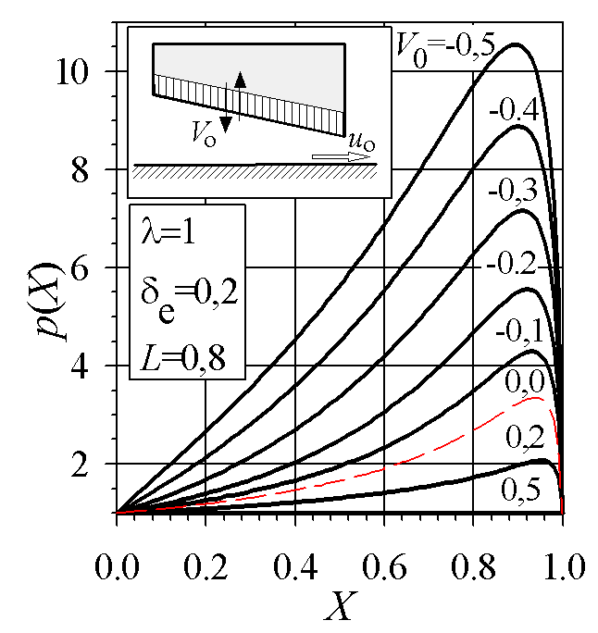

**Figure 1.** Title (Calibri 11 pt, Center)

It is important that all numbers and characters appearing in figures are of good quality and well-readable size (≈ 11 pt). Axes labels must be clearly denoted.

All tables should be incorporated into the main body of the text and must be centred in the column and numbered consecutively. Place tables as close as possible to where they are mentioned in the main text. Large tables may span both columns.

**Table 1.** Heading (Calibri 11 pt, Align Left)

|  |  |  |  |  |
| --- | --- | --- | --- | --- |
| Element | Chemical composition [%] | | | |
| SiO2 | Al2O3 | Fe2O3 | CaO |
| Cordierite (C) | 45.52 | 28.10 | 1.23 | 3.70 |
| Talc (T) | 62.20 | 3.11 | 1.25 | 1.07 |

Table headings should be placed above the table, as shown in this template. The width of all lines in tables including all borders should be 1/2 pt. Text and numbers in tables should be typewritten in Calibri 11 pt.

It is recommended that footnotes be avoided. Instead, try to integrate the footnote information into the text.

1. CONCLUSION (calibri 12 pt, all caps, bold, Align left)

Although a conclusion may review the main points of the paper, do not replicate the abstract as the conclusion. A conclusion might elaborate on the importance of the work or suggest applications and extensions.

**ACKNOWLEDGEMENT (calibri 12 pt, all caps, bold, Align left)**

If you have some expression of gratitude for assistance or financial support, it should be written after the conclusion.

**REFERENCES (calibri 12 pt, all caps, bold, Align left)**

References are to be listed in the order of their appearance in the text and numbered. Citation is by the number only which is to be put in square brackets, i.e. [1,2], [3], ... etc. Please note that all references listed here must be directly cited in the body of the text.

In the reference list (Calibri 11 pt, Justify, Hanging 0.75 cm), journal papers [1], books [2], multi-author books [3], theses [4], conference Proceedings [5], standards [6,7] and websites [8] should be cited as in the following examples:

1. H. Czichos, D. Klaffke, E. Santner, M. Woydt: Advances in tribology: the materials point of view, Wear, Vol. 190, No. 2, pp. 155-161, 1995.
2. A.W. Gross: *Gas Film Lubrication*, John Wiley and Sons, New York, 1992.
3. G.W. Stachowiak: Numerical characterization of wear particle morphology, in: I.M. Hutchings (Ed.): *New Directions in Tribology*, Mechanical Engineering Publications Ltd., Bury St Edmunds, pp. 371-389, 1997.
4. J. Stokes: *Production of Coated and Free-Standing Engineering Components using the HVOF (High Velocity Oxy-Fuel) Process*, PhD thesis, School of Mechanical and Manufacturing Engineering, Dublin City University, Dublin, 2003.
5. J.K. Lancaster: Severe metallic wear, in: *Proceedings of the Conference on Lubrication and Wear*, 01-03.10.1957, London, UK, pp. 1-7 or Paper 7
6. ASTM G77-98 *Standard Test Method for Ranking Resistance of Materials to Sliding Wear Using Block-on-Ring Wear Test*, 1998.
7. ISO 14577-1, *Metallic Materials – Instrumented Indentation Test for Hardness and Materials Parameters – Part 1: Test Method*, 2002.
8. Fluid bearing, available at: http://en.wikipedia. org/wiki/Fluid_bearing, accessed: 29.06.2005.